- 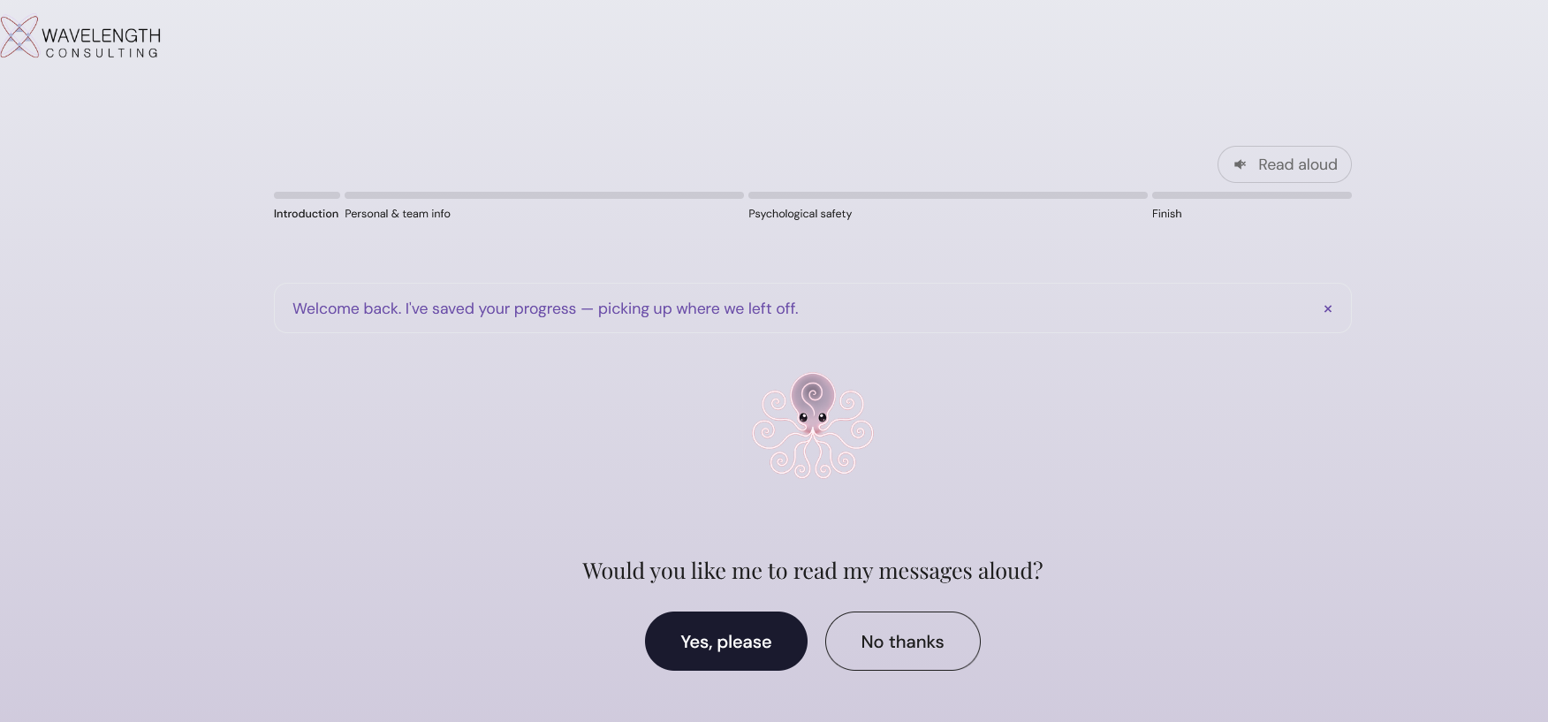
  - Here’s the opening screen. The progress bar is so tiny. I want the bar itself and the text to be bigger. Aso the ‘welcome back’. Do this. Look up best practices and inclusivity in usability. What font size, minimum, is kind to different eye-sights. What colors are bad for color-blind people. Then consider our text and the files you’ve seen…I want to apply these usability and visability human factors principals. If you find any more violations of basic usability and human factors principles that you realize or notice, please flag them.
  - Another thing. I know that I told you that I don’t want us to be able to click forward on the progress bar. BUT if someone has already reached and advanced forward to say, the psych safety section. Thin I think we should allow them to click back there. Is there a way to allow this adaptively, depending on if someone has already reach that place?
  - Another strange things is that when the audio first plays on the opening page, it’s a female voice. Then it switches to a male voice later. Can we always keep it male?
- 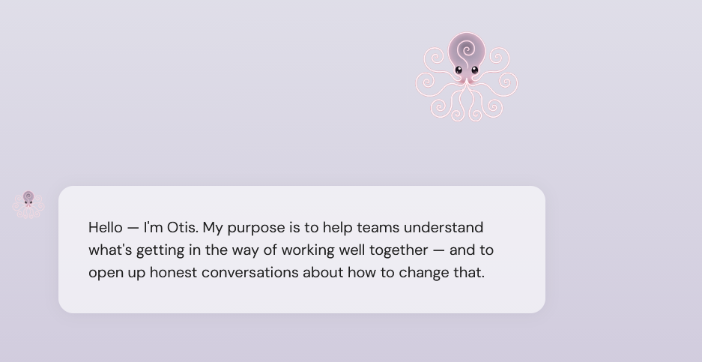
  - For the entire introduction section, I want the chat bubble to be centered below the big Otis icon, not off to the side. And remove the tiny Otis octopus who’s to the left of the chat bubbles.
  - So once it gets to the personal info & team section, we removed the big Otis, right? So that’s why it’s ok to keep the little Otis.
- 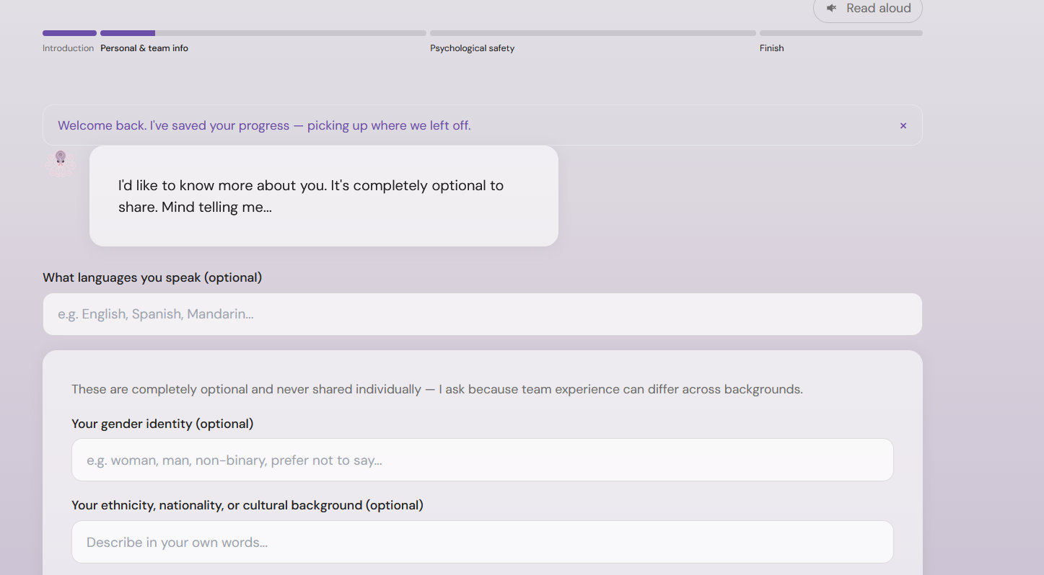
  - I noticed that I filled this in already, and the information didn’t save…so maybe we need to make sure that Otis is actually saving information when it’s filled in for all fields, in the entire survey.
- 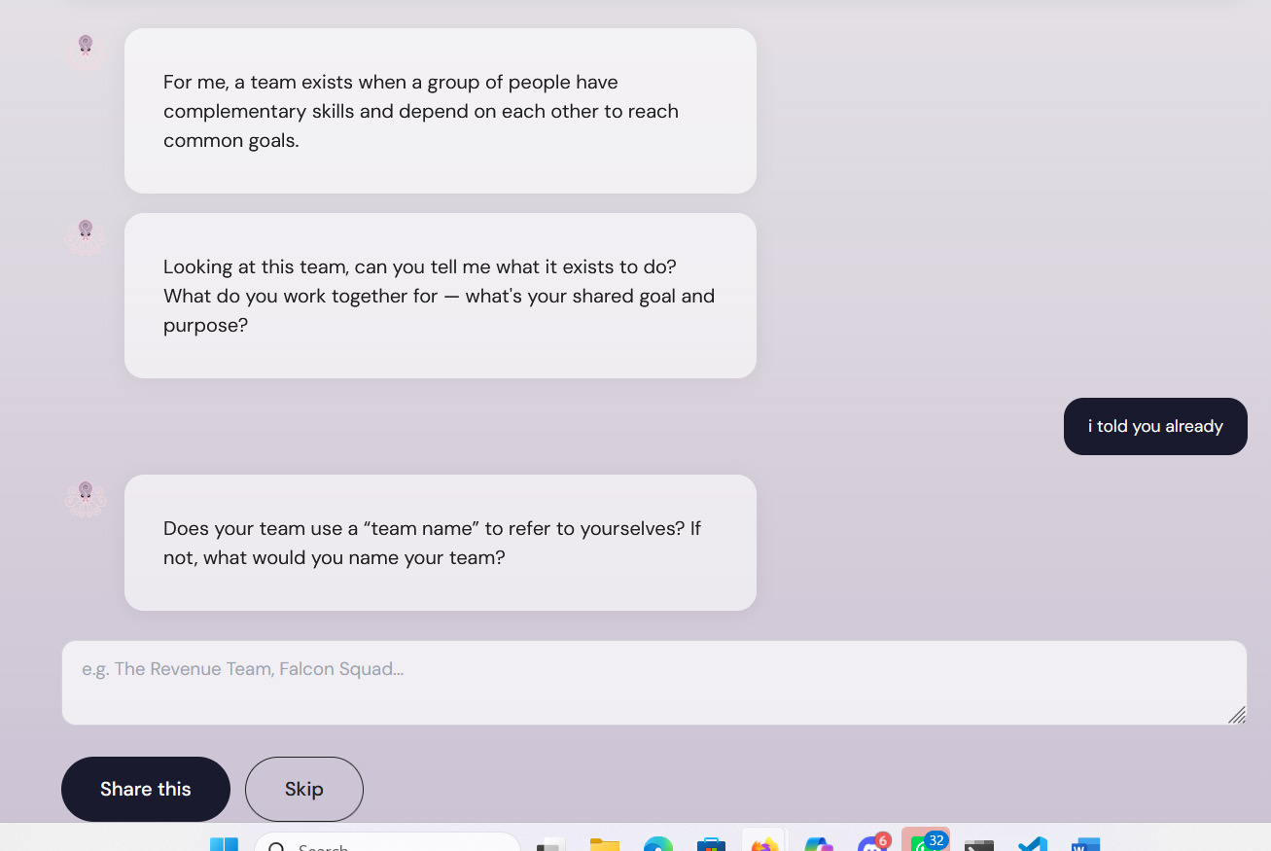
  - The same issue regarding the ‘team name’ was not saved, even when I went forward in the assessment and then came back, the name had not saved even though it was written in the box I still had to press ‘share this ‘ again.
  - On this page we see another isses, thati still can’t edit the previous chats and the message I had written earlier before the ‘I told you already’ wasn’t saved. Actually, I think we might want to ask the ‘team name’ question on a separate page. So why don’t you make another page with the roster, and below the rosert ask the ‘team name’ question. Any time Otis is satisfied with a mamber’s answers, it’s fine for Otis to stop prompting, but there shouldbe an option for a person to keep chatting. For example, they might think of something else to say.
- 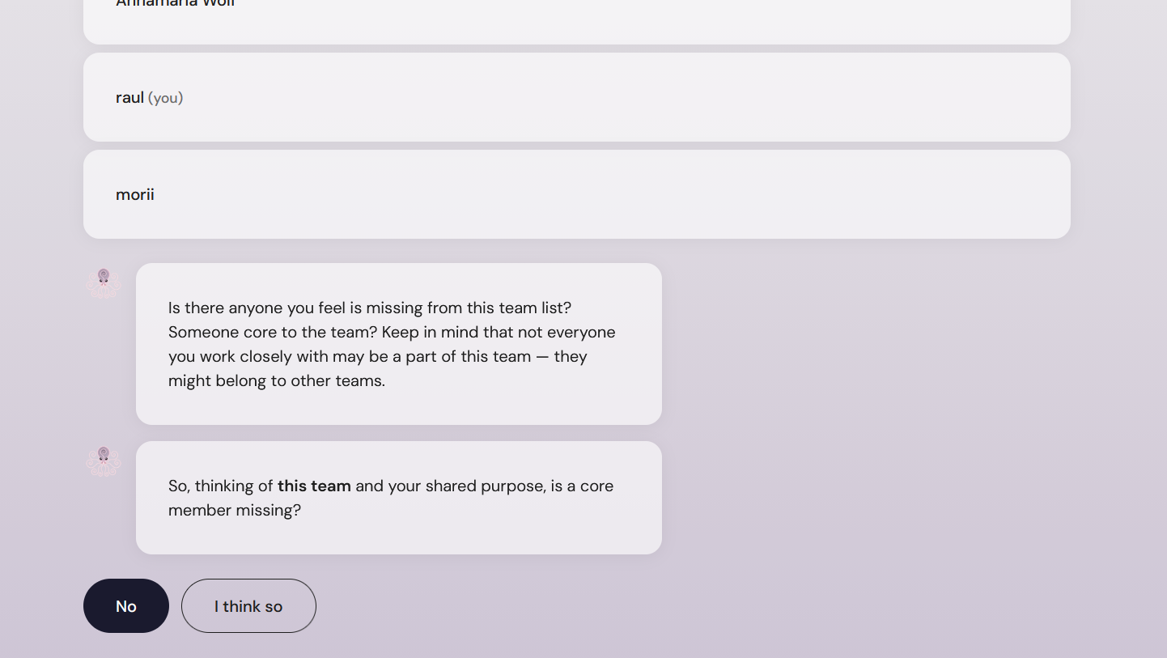
  - Again, I had added a member and it didn’t save, I guess. I’m not sure if it saved in the background, but from the user’s perspective it didn’t. and if they fill in the fields multiple times, I don’t know what messiness that’s creating in the dashboard. We need to think about how things are landing in the dashboard.
- 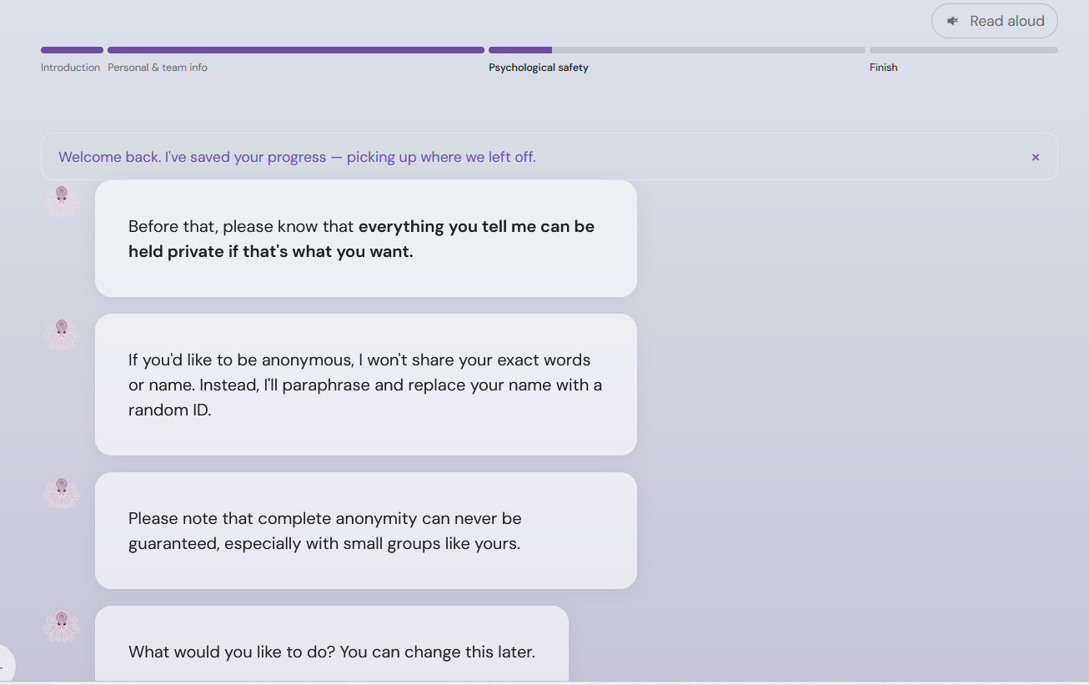
  - When we have multiple bubbles like this, I’d like for us to be able to click on each bubble and then the audo plays from that point. If the ‘read aloud’ is on, and I click on the 4th bubble, it starts playing from there and moving down.
- In the FAQ section, I’d like for Otis to be able to answer questions. I think Otis should have some kind of a Q&A it pulls from, or it defaults to ‘ I can’t answer that, but I’ll make a note of that so that someone can answer’. . it can be an anonymous note if, and Otis can specify this if the user previously chose to not share their identity.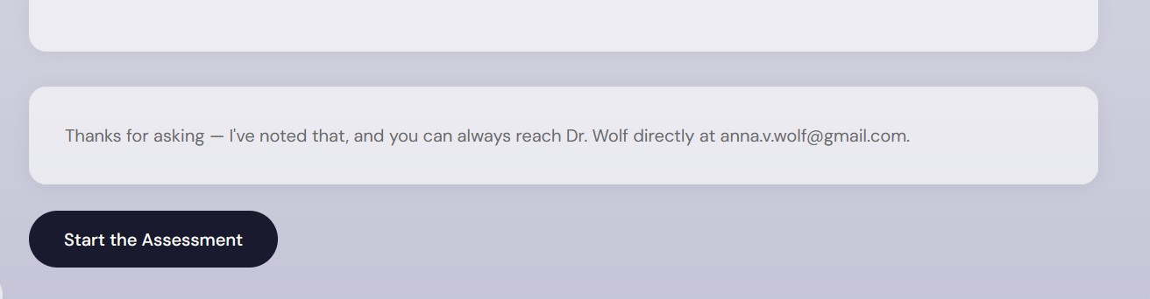
- otis doens't read the title, it should. and can we move the middle text bubble up just a bit it should essentially be exactly in the middle of the other two text bubbles.
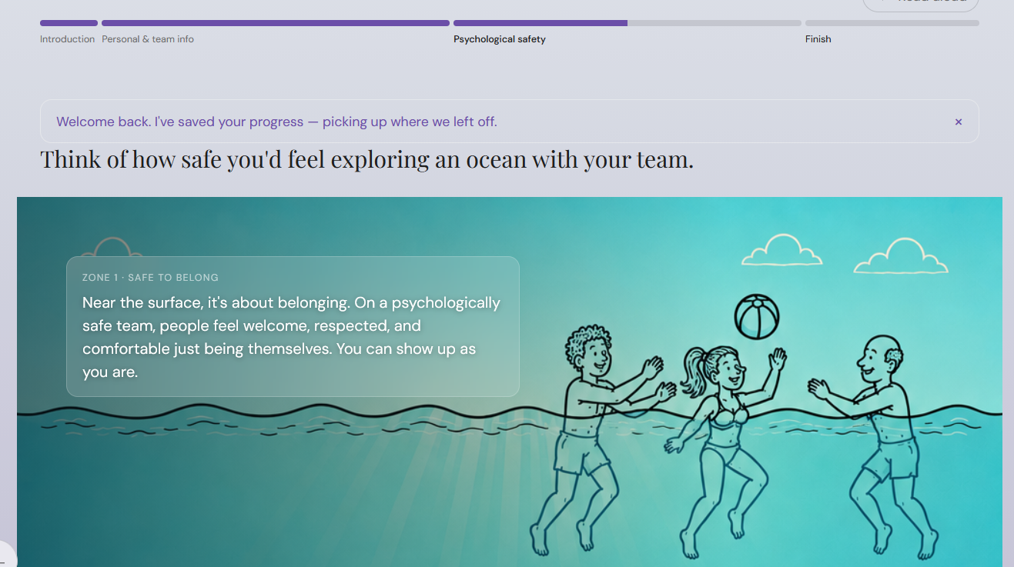
  - Another issue with this is that the ‘zone 1 safe to belong’ text is super small. Lets make this bigger (going back to my previou request that we think of usability and inclusivity and look at minimum standards for text size, you might make a decisoin about how big it should be)
- 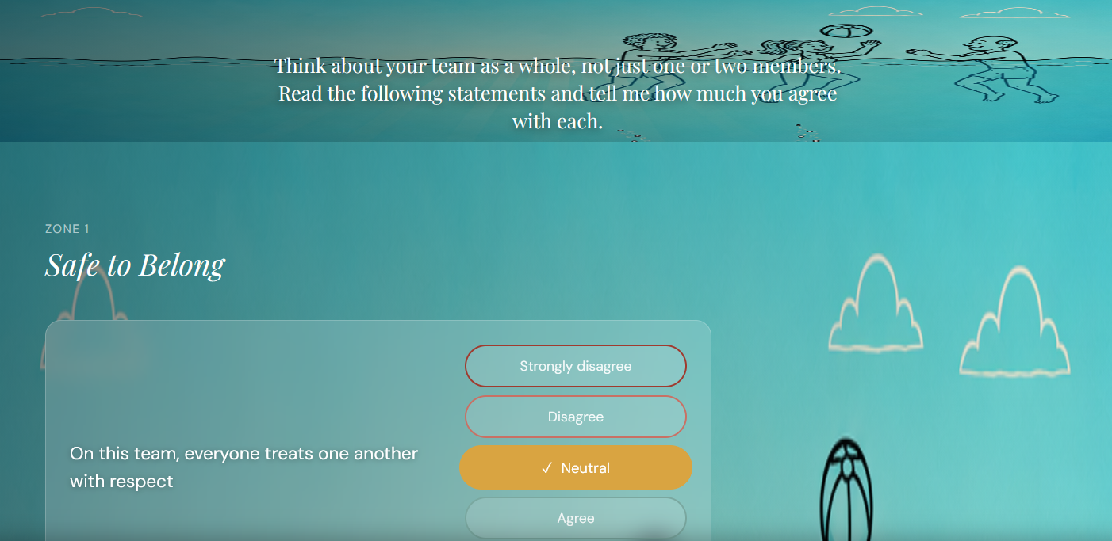
there's something weird going on here....looking at the top where that white text is reading 'Think about your team as a whole, not just one or two members. Read the following statements and tell me how much you agree with each.' it has it's own strange background that runs along like a banner. If you take a look at the previous bullet points, which shows an image of the revious page in the app that where we introduce the psych safety zones, I want to duplicate this page and the only things that change is instead of the title that reads’ Thing of how safe you’d feel exploring an ocean with your team’ it should say ‘Thinking about your team as a whole, how much do you agree with the following statements”. And then instead of the ‘Psych Safety zones’, we have the survey items, which might need to be adjusted a little bit depending on if the size of the background image changes, why still have to fit inside.
- 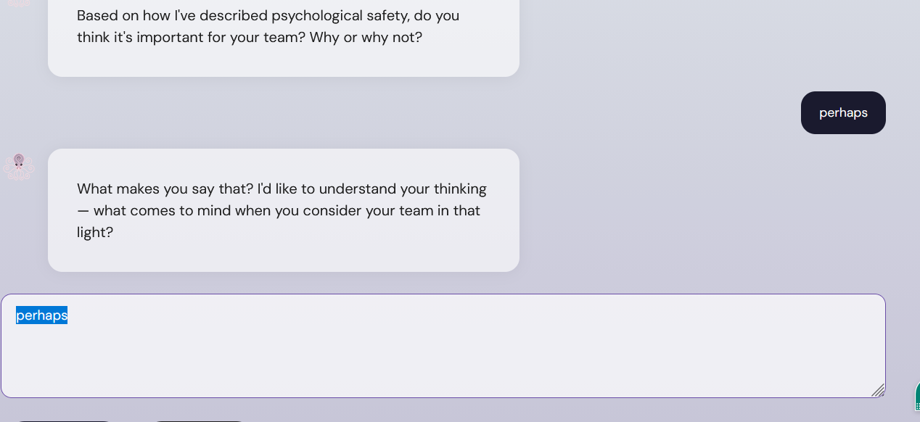
  - Otis’s prompting here didn’t make total sense ‘in that light’ … do we need to refine guidelines for prompting in every field? What’s your recomendation
  - 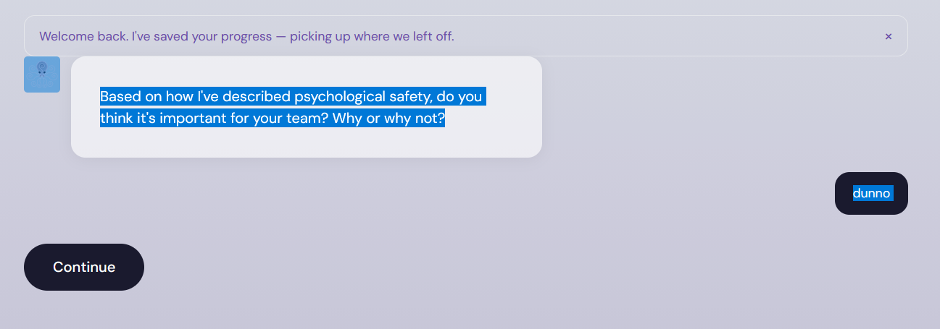
    - Here again we don’t retain the previous message the user put in, after I said ‘perhaps’ I said ‘dunno’ but that disappears. And again, no way to add more text if I wanted to.
- 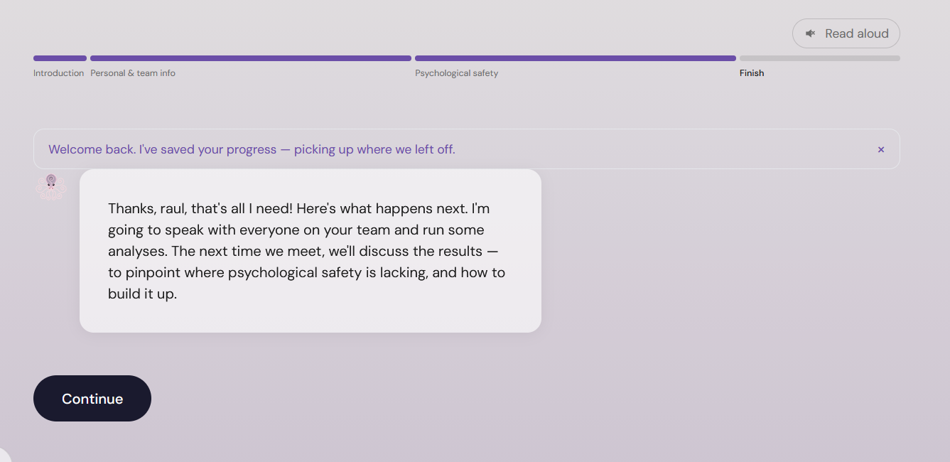
I’d like for little Otis to go away and big Otis to return, floating above. Also center the chat bubble under Otis.
- 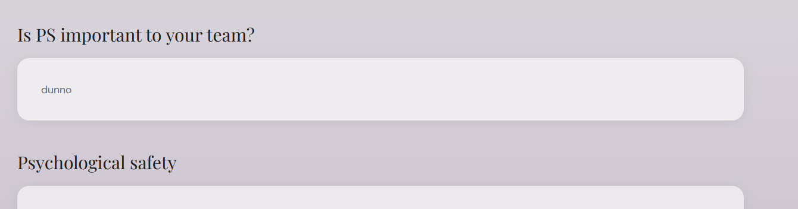
This is the ending report, make sure we can edit everything here. And we have do be mindful of how multiple chats show up in the end report. We might want to show not only what the user said but what Otis said. If there was a back and forth between them, maybe the user can edit the individual bubbles if they want to…if you have ideas or think something could go worng here lmk.
- 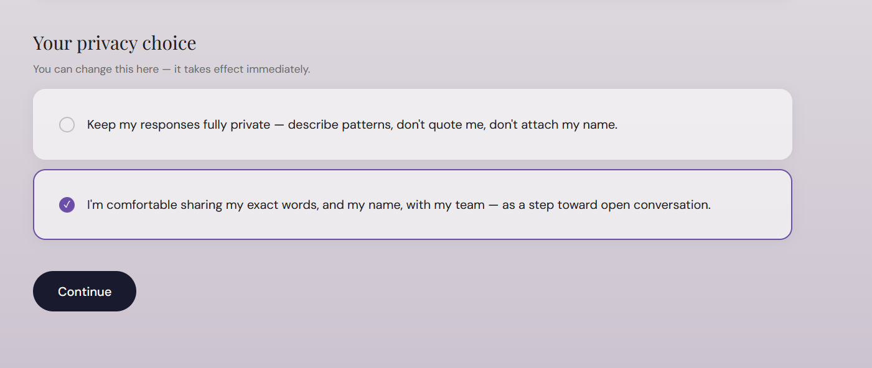
Here we could have ‘opt out’, I think I promised this. So something like ‘ I would like to opt-out of participating in this assessment – delete all of my results’. We need to flag this in the dashboard if someone does this. Another thing, make this a different color and have another check, like ‘Are you sure? Your data will be deleted’. Like a 2 step process. How would this work along with anonymity… like, they could still be anonymous in this case? What’s thoughr thought do not want to participate in this

